<E-Commerce Web Application For Selling Digital Products>

Software Development Plan

Version <1.5>

Revision History

| **Date** | **Version** | **Description** | **Author** |
| --- | --- | --- | --- |
| 30/May/24 | <1.0> | Complete part 1 | Nguyễn Kim Anh |
| 02/Jun/24 | <1.1> | Complete part 2, 3 | Nguyễn Kim Anh |
| 05/Jun/24 | <1.2> | Modify organization diagram part 3 | Nguyễn Kim Anh |
| 06/Jun/24 | <1.3> | Modify organization role part 3 | Nguyễn Kim Anh |
| 06/Jun/24 | <1.4> | Modify project monitoring and control, Project Plan, Project Schedule | Quách Trần Quán Vinh |
| 07/Jun/24 | <1.5> | Complete project estimate | Nguyễn Kim Anh |
| 10/Jul/24 | <1.6> | Modify Gantt chart | Nguyễn Kim Anh |

Table of Contents

**+ 4**

**1. Introduction 4**

*1.1 Document Purpose 4*

*1.2 Scope 4*

**2. Project Overview 4**

*2.1 Project Purpose, Scope, and Objectives 4*

*2.2 Assumptions and Constraints 5*

*2.3 Project Deliverables 5*

**3. Project Organization 5**

*3.1 Organizational Structure 5*

*3.2 Roles and Responsibilities 6*

**4. Management Process 7**

*4.1 Project Estimates 7*

*4.2 Project Plan 7*

4.2.1 Phase and Iteration Plan 7

4.2.2 Releases 8

4.2.3 Project Schedule 8

*4.3 Project Monitoring and Control 13*

4.3.1 Reporting 13

4.3.2 Risk Management 13

4.3.3 Configuration Management 13

Software Development Plan

# 

# Introduction

This part of the document presents an overview of the project, including its goals, the chosen development approach, and the scope of this plan.

## Document Purpose

This document serves two primary purposes. First, it acts as a roadmap, guiding the project execution by outlining the planned schedule and key milestones. Second, it functions as a management tool, helping to allocate resources and techniques effectively throughout the development process. It details the methodologies used at each stage of the project.

## Scope

This document outlines the plan for developing an E-Commerce web application designed for selling digital products. It details the specific aspects covered in the Vision Document, including product requirements, core functionalities, development phases (initial development, ongoing maintenance) and technical specifications that will guide the development process.

# Project Overview

## Project Purpose, Scope, and Objectives

The purpose of this project is to develop a user-friendly e-commerce web application specifically designed for selling digital products. This application will bridge the gap between business offering digital products and their customers, enabling a smooth, efficient, and convenient online shopping experience. Serves as an online platform to sell and buy electronic items. Sellers can use our website to showcase and sell their products while the buyers (users that are registered and logged in) can buy them and have them delivered.

The project scope encompasses the development of the core functionalities essential for an e-commerce platform dealing in digital products. This includes:

* Product Management: A system for adding, deleting, updating, and managing product information, descriptions, pricing, and inventory.
* Customer Interface: A user-friendly and intuitive interface for browsing products, searching by category or keyword, and adding items to a shopping cart.
* Order Management: An automated system to manage orders: manage order history for both customers and businesses, announce shipping status or shipping time, allow customers to apply voucher for order
* User Accounts and Management: A system for user registration, login, and account management, allowing customers to track order history, update personal information.

Objective:

* Enhance Customer Experience: Provide a user-friendly and intuitive platform for customers to browse, search, and purchase digital products with ease.
* Simplify Business Operations: Offer a streamlined system for a business to manage their digital product inventory, process orders, and track sales.

## Assumptions and Constraints

Assumptions:

* Technical Expertise: Team members possess the necessary skills and have experience using online shopping standard
* Project Timeline: All project phases are on schedule
* Project quality: Complete final product with minimal bugs.

Constraints:

* Budget: zero budget
* Schedule: 3 months
* Timeline: project must be completed on schedule
* Security: user passwords must be securely stored using a strong hashing algorithm - bcrypt
* Tool: Work with some required tools: Github, Trello, Slack, Google Drive

## Project Deliverables

* Target delivery date for final product: 12/Aug/24
* Final product: E-Commerce Web Application named Electronics Defiant Store
* Requirements documents:
* Project plan
* Vision document
* Software architecture document
* Weekly report

# Project Organization

## Organizational Structure



## Roles and Responsibilities

| ***Person*** | ***Role*** |
| --- | --- |
| **Ngô Hải Bằng**  *Project Manager, Front-end developer* | Oversees the entire project, keeping everyone on track and communicating effectively.  Manages resources (people, budget, time) and ensures project goals are met. Also plans and track progress on schedule based on timeline  Develops the user interface (UI) of the web application, focusing on visual elements and user interaction.  Collaborates with the content designer on implementing the design into the front-end code.  Assign tasks, monitor and report status (weekly report), coordinate meetings and contact point for the project |
| **Nguyễn Kim Anh**  *Back-end developer, Tester* | *Builds the server-side logic of the web application, handling data processing, database interactions, and application functionalities.*  *Collaborates with front-end developers to ensure smooth integration between UI and server-side logic.*  *Identify bug, reports defects and works with developers to fix bug* |
| **Lê Bảo Giang**  *Content designer*  *UI/UX designer* | *Design the content layout, visual of the web application (collaboration with team leader)*  *Focus the UX - user experience to suggest and build the layout and content clearly and engaging* |
| **Đinh Vũ Huân**  *Back-end developer*  *Business analyst* | *Handling data processing, database interactions, and application functionalities.*  *Collaborates with front-end developers to ensure smooth integration between UI and server-side logic.*  *Responsible for document requirements, communicate with team members about the requirements and coordinate to review requirements* |
| **Quách Trần Quán Vinh**  *Back-end developer, Tester* | *Builds the server-side logic of the web application, handling data processing, database interactions, and application functionalities.*  *Collaborates with front-end developers to ensure smooth integration between UI and server-side logic.*  *Creates test cases to identify bugs and ensure the application functions correctly.* |

# Management Process

## Project Estimates

* Development team:
* Number of members: 5 members
* Other knowledge is mainly free materials available on YouTube and free programming websites and slides from lecturers..
* Planning and designing web application: 83 hours
* Learning how to use new frameworks, programming languages and methodologies: NodeJs, MongoDB, HTML, CSS…: 36 hours
* Layout design: 10 hours
* Design data model: 5 hours
* Design architecture: 32 hours
* Constructing web applications: 335 hours
* Implement CRUD features: 240 hours
* Implement additional features: 90 hours
* Report the progress of project every week: 5 hours
* Web application completion: 89 hours
* Testing after done a features: 36 hours
* Testing all system after every release: 3 hours
* Fix bug after testing: 50 hours
* Deployment cost: 0
* Project progress estimate:
* Project research and knowledge building: 36 hours = 1.5 days
* Project development: 3 months
* Start time: 13/May/24
* End time: 08/May/24

If there are any changes in customer requirements or other factors, the project cost and schedule will be recalculated and estimated.

## Project Plan

This section contains the schedule and resources for the project.

### **Phase and Iteration Plan**

There are 3 main phases in our project, namely Inception Phase, Elaboration Phase and Construction Phase. Here is a timeline of the project:



We also specify objectives for each phase:

* Inception phase:
  + Establish the project foundation and stakeholders’ agreement.
* Elaboration phase:
  + Refine the requirements of project
  + Define executable architecture baseline
  + Define software architecture description
  + Create a detailed project plan
* Construction phase:
  + Develop the e-commerce application iteratively
  + Test case and result
  + Release milestone

### **Releases**

As estimated, our project will have two build release milestones every sprint. In the middle of sprint 5 and at the end of sprint 6, there will be a beta release and a demo release respectively.

Every release is to make sure that our project will run properly. If there are any bugs, we may tackle them as soon as we detect them.

### **Project Schedule**

Here is a Gantt chart showing the schedule of phases, iterations and tasks throughout the project, along with the resources allocation of each task:

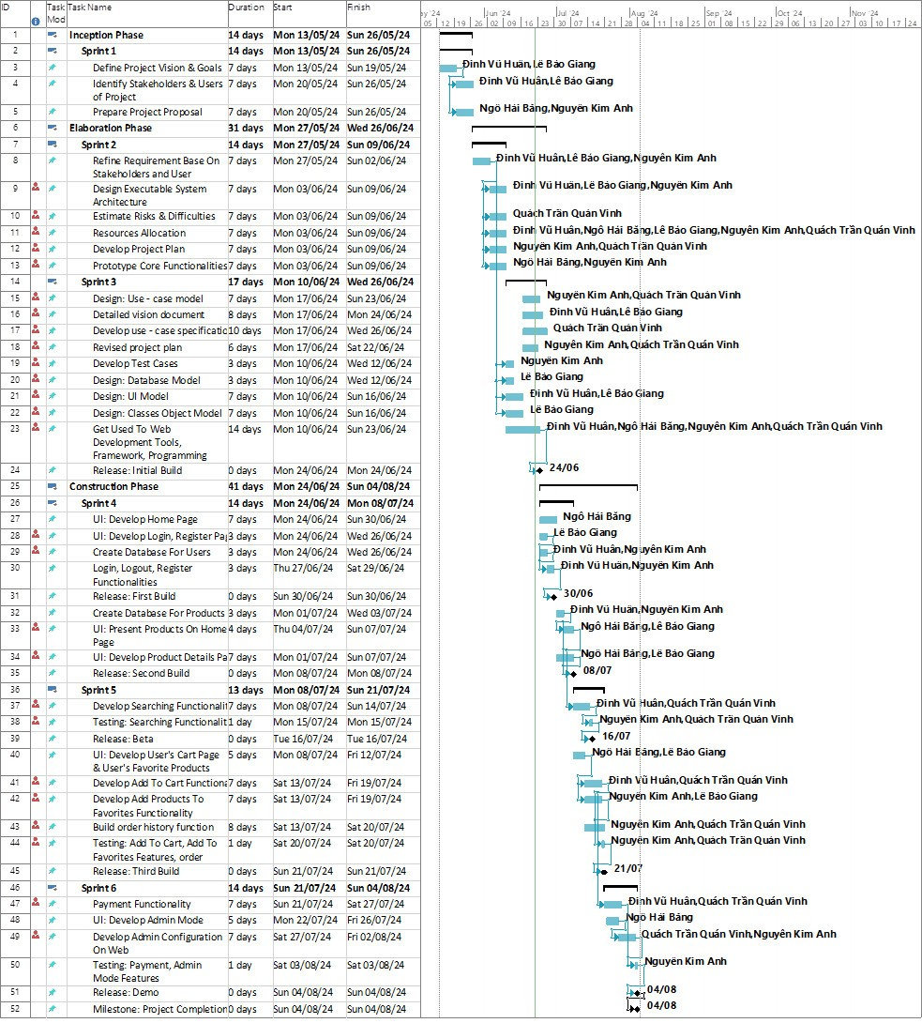

Here is a table showing the schedule of phases, iterations and tasks throughout the project, along with the resources allocation of each task:

| **Task Name** | **Duration** | **Start** | **Finish** | **Resource Names** |
| --- | --- | --- | --- | --- |
| **Inception Phase** | **14 days** | **Mon 5/13/24** | **Sun 5/26/24** |  |
| **Sprint 1** | **14 days** | **Mon 5/13/24** | **Sun 5/26/24** |  |
| Define Project Vision & Goals | 7 days | Mon 5/13/24 | Sun 5/19/24 | Đinh Vũ Huân,Lê Bảo Giang |
| Identify Stakeholders & Users of Project | 7 days | Mon 5/20/24 | Sun 5/26/24 | Đinh Vũ Huân,Lê Bảo Giang |
| Prepare Project Proposal | 7 days | Mon 5/20/24 | Sun 5/26/24 | Ngô Hải Bằng,Nguyễn Kim Anh |
| **Elaboration Phase** | **28 days** | **Mon 5/27/24** | **Mon 6/24/24** |  |
| **Sprint 2** | **14 days** | **Mon 5/27/24** | **Sun 6/9/24** |  |
| Refine Requirement Base On Stakeholders and User thought | 7 days | Mon 5/27/24 | Sun 6/2/24 | Đinh Vũ Huân,Lê Bảo Giang,Nguyễn Kim Anh |
| Design Executable System Architecture | 7 days | Mon 6/3/24 | Sun 6/9/24 | Đinh Vũ Huân,Lê Bảo Giang,Nguyễn Kim Anh |
| Estimate Risks & Difficulties | 7 days | Mon 6/3/24 | Sun 6/9/24 | Quách Trần Quán Vinh |
| Resources Allocation | 7 days | Mon 6/3/24 | Sun 6/9/24 | Đinh Vũ Huân,Ngô Hải Bằng,Lê Bảo Giang,Nguyễn Kim Anh,Quách Trần Quán Vinh |
| Develop Project Plan | 7 days | Mon 6/3/24 | Sun 6/9/24 | Nguyễn Kim Anh, Quách Trần Quán Vinh |
| Prototype Core Functionalities | 7 days | Mon 6/3/24 | Sun 6/9/24 | Ngô Hải Bằng,Nguyễn Kim Anh |
| **Sprint 3** | **14 days** | **Mon 6/10/24** | **Mon 6/24/24** |  |
| Develop Test Cases | 3 days | Mon 6/10/24 | Wed 6/12/24 | Nguyễn Kim Anh |
| Design Use-case Model | 7 days | Mon 17/6/24 | Sun 23/6/23 | Nguyễn Kim Anh, Quách Trần Quán Vinh |
| Develop Use-case Specification | 10 days | Mon 17/6/24 | Wed 26/6/24 | Quách Trần Quán Vinh |
| Design: Database Model | 3 days | Mon 6/10/24 | Wed 6/12/24 | Lê Bảo Giang |
| Design: UI Model | 7 days | Mon 6/10/24 | Sun 6/16/24 | Đinh Vũ Huân,Lê Bảo Giang |
| Design: Classes Object Model | 7 days | Mon 6/10/24 | Sun 6/16/24 | Lê Bảo Giang |
| Get Used To Web Development Tools, Framework, Programming Languages | 14 days | Mon 6/10/24 | Sun 6/23/24 | Đinh Vũ Huân,Ngô Hải Bằng,Nguyễn Kim Anh,Quách Trần Quán Vinh |
| Detailed vision document | 8 days | Mon 17/6/24 | Mon 24/6/24 | Đinh Vũ Huân, Lê Bảo Giang |
| Revised project plan | 5 days | Mon 17/6/24 | Sat 22/6/24 | Nguyễn Kim Anh, Quách Trần Quán Vinh |
| Release: Initial Build | 0 days | Mon 6/24/24 | Mon 6/24/24 |  |
| **Construction Phase** | **41 days** | **Mon 6/24/24** | **Sun 8/4/24** |  |
| **Sprint 4** | **14 days** | **Mon 6/24/24** | **Mon 7/8/24** |  |
| UI: Develop Home Page | 7 days | Mon 6/24/24 | Sun 6/30/24 | Ngô Hải Bằng |
| UI: Develop Login, Register Page | 3 days | Mon 6/24/24 | Wed 6/26/24 | Lê Bảo Giang |
| Create Database For Users | 3 days | Mon 6/24/24 | Wed 6/26/24 | Đinh Vũ Huân,Nguyễn Kim Anh |
| Login, Logout, Register Functionalities | 3 days | Thu 6/27/24 | Sat 6/29/24 | Đinh Vũ Huân,Nguyễn Kim Anh |
| Release: First Build | 0 days | Sun 6/30/24 | Sun 6/30/24 | Quách Trần Quán Vinh |
| Create Database For Products | 3 days | Mon 7/1/24 | Wed 7/3/24 | Đinh Vũ Huân,Nguyễn Kim Anh |
| UI: Present Products On Home Page | 4 days | Thu 7/4/24 | Sun 7/7/24 | Ngô Hải Bằng,Lê Bảo Giang |
| UI: Develop Product Details Page | 7 days | Mon 7/1/24 | Sun 7/7/24 | Ngô Hải Bằng,Lê Bảo Giang |
| Release: Second Build | 0 days | Mon 7/8/24 | Mon 7/8/24 |  |
| **Sprint 5** | **13 days** | **Mon 7/8/24** | **Sun 7/21/24** |  |
| Develop Searching Functionality | 7 days | Mon 7/8/24 | Sun 7/14/24 | Đinh Vũ Huân,Quách Trần Quán Vinh |
| Testing: Searching Functionality | 1 day | Mon 7/15/24 | Mon 7/15/24 | Nguyễn Kim Anh,Quách Trần Quán Vinh |
| Release: Beta | 0 days | Tue 7/16/24 | Tue 7/16/24 |  |
| UI: Develop User's Cart Page & User's Favorite Products Page | 5 days | Mon 7/8/24 | Fri 7/12/24 | Ngô Hải Bằng,Lê Bảo Giang |
| Develop Add To Cart Functionality | 7 days | Sat 7/13/24 | Fri 7/19/24 | Đinh Vũ Huân,Quách Trần Quán Vinh |
| Develop Add Products To Favorites Functionality | 7 days | Sat 7/13/24 | Fri 7/19/24 | Nguyễn Kim Anh,Lê Bảo Giang |
| Testing: Add To Cart, Add To Favorites Features | 1 day | Sat 7/20/24 | Sat 7/20/24 | Nguyễn Kim Anh,Quách Trần Quán Vinh |
| Release: Third Build | 0 days | Sun 7/21/24 | Sun 7/21/24 |  |
| **Sprint 6** | **14 days** | **Sun 7/21/24** | **Sun 8/4/24** |  |
| Payment Functionality | 7 days | Sun 7/21/24 | Sat 7/27/24 | Đinh Vũ Huân,Quách Trần Quán Vinh |
| UI: Develop Admin Mode | 5 days | Mon 7/22/24 | Fri 7/26/24 | Ngô Hải Bằng |
| Develop Admin Configuration On Web | 7 days | Sat 7/27/24 | Fri 8/2/24 | Quách Trần Quán Vinh,Nguyễn Kim Anh |
| Testing: Payment, Admin Mode Features | 1 day | Sat 8/3/24 | Sat 8/3/24 | Nguyễn Kim Anh |
| Release: Demo | 0 days | Sun 8/4/24 | Sun 8/4/24 |  |

## Project Monitoring and Control

### **Reporting**

* Report the processes (included backlogs, updating) and budget of the project, status of each member by holding weekly meetings via Google Meets and written weekly reports
* Report the accomplished tasks in Trello.
* Informal chat between members

### **Risk Management**

### **Configuration Management**

* Git: store source codes and project relative files.
* Google Drive: store weekly reports, weekly project assignments.